Create a custom docker image for nginx and deploy it using docker-compose, where the volume mount should be at /var/opt/nginx location. Push the created custom docker image to your docker hub.



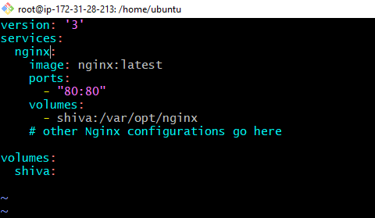

To run the docker compose

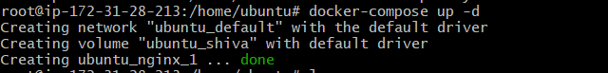

To view the containeraize status

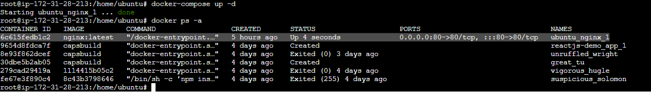

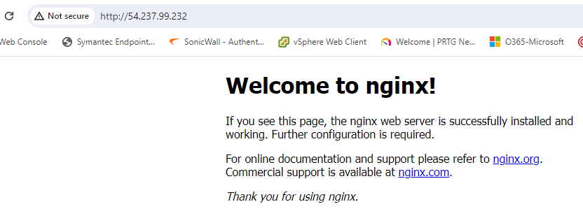

To Push the images to docker hub

<https://hub.docker.com/repository/docker/ssivaneswaran/guvi-task/general>

